8.49: See Exercise 8.47(a); with 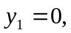 Eq. (8.28) gives 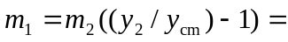 so the total mass of the system is 1.25 kg.

b) 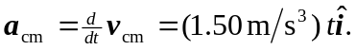
c)

